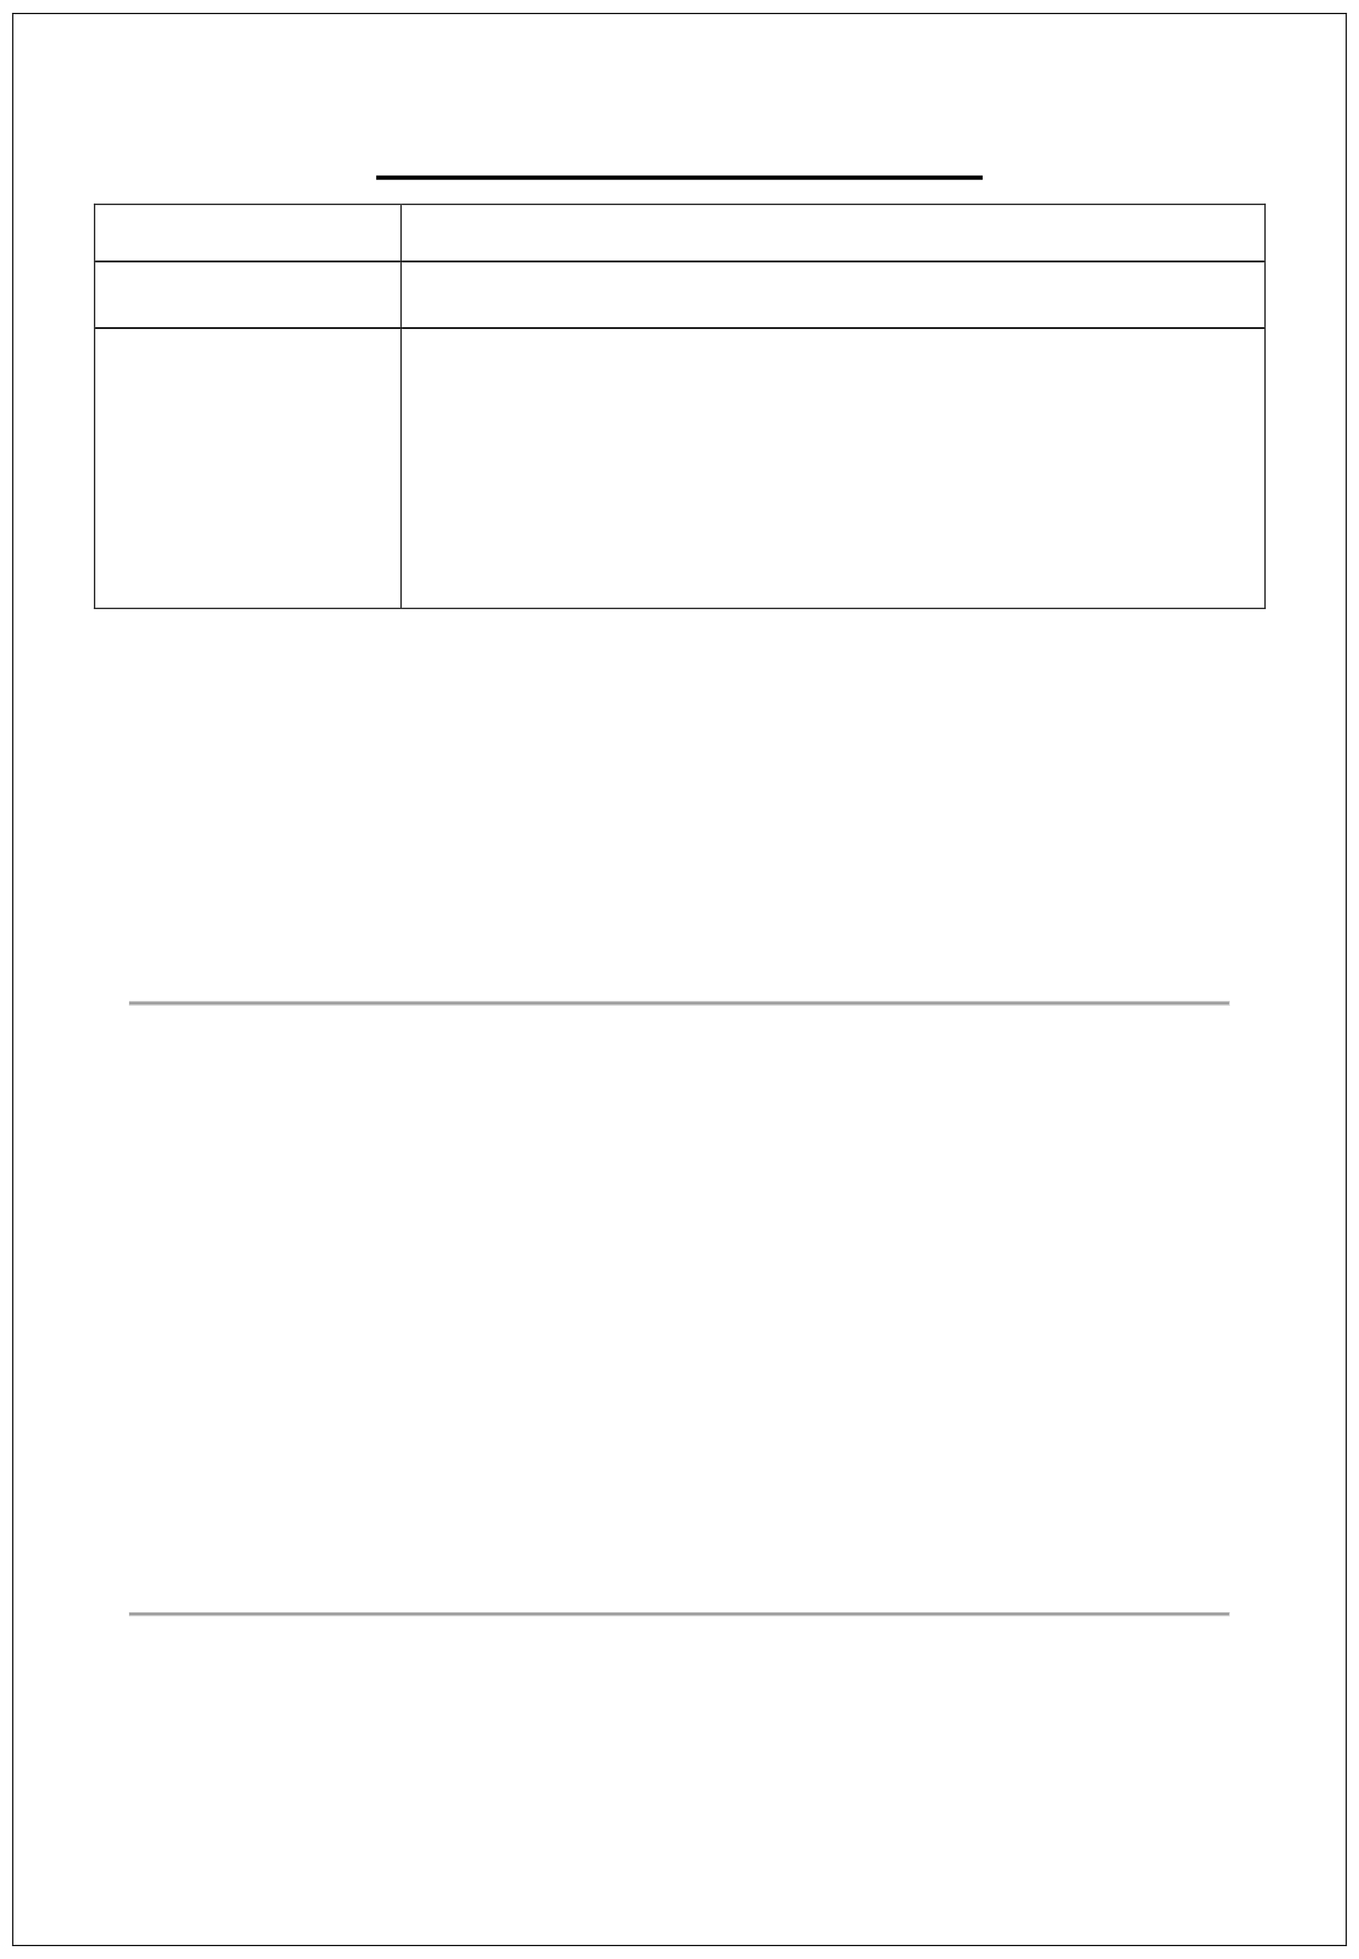

Team ID Project Name
Team Members

PROJECT PLANNING PHASE
NM2025TMID04832
Medical Inventory Management System

AAMEER MOHAMED N (Reg.No:910322104001)
AJITH M (Reg.No:910322104004)
KARUPPAIAH A (Reg.No: 910322104024)
SUTHAKAR M (Reg.No:910322104056)

Folder Reference: Document/ProjectPlanning Phase/ Includes:
- Project Planning (1).pdf
- Readme.md

- Milestones and Phases Milestone Description
- Requirement Gathering & Feasibility Study
- System Design & Architecture
- Backend & Database Development
- Frontend Interface Development
- Integration & Testing
- Deployment & Maintenance

- Resource Planning Resource Responsibility
Project Manager Planning, coordination

Developers QA Engineers
Backend & frontend development Testing and validation

Database Admin Data schema design UI/UX Designer Interface prototyping
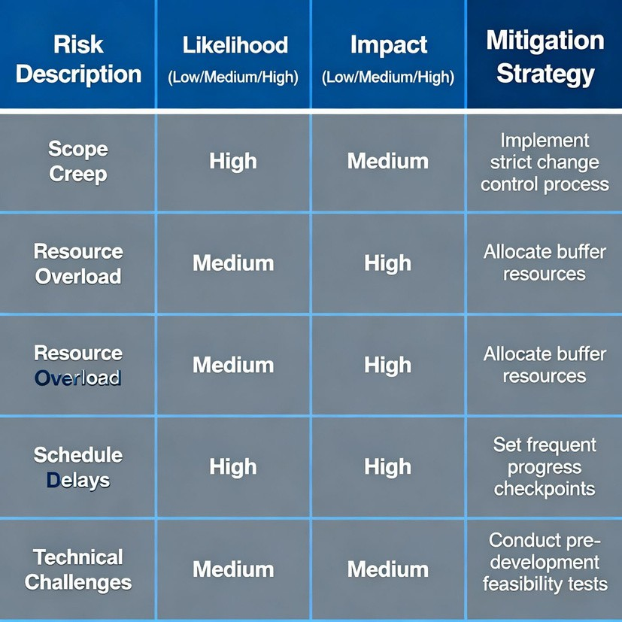

- Timeline
Phase Duratio
n


Ideation & Requirement Analysis Design & Architecture Implementation
Testing & Debugging Deployment
2 Weeks
3 Weeks
4 Weeks
2 Weeks
1 Week

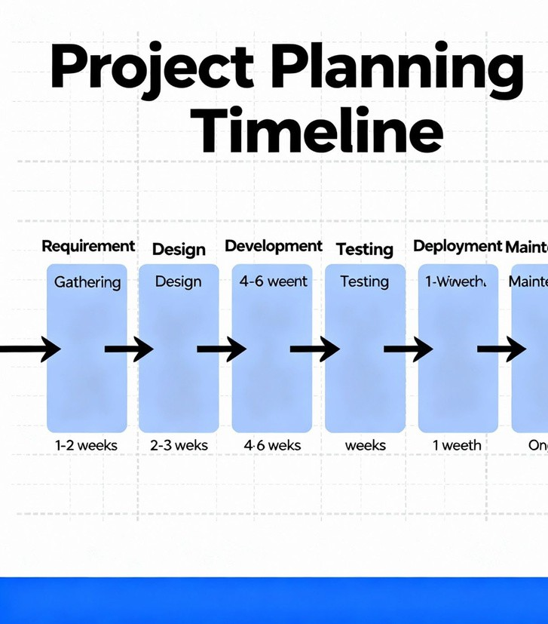
Phase

- Risk Management Risk
Server downtime
Data corruption

Mitigation
Cloud-based backup Scheduled database backups
Duratio n

Delayed procurement Automated reorder alerts

